International Network for School Social Work

http://internationalnetwork-schoolsocialwork.htmlplanet.com

Contact mhuxtable@olympus.net



Electronic Newsletter April 2009

Auckland
4th International
School Social Work Conference
April 14 – 17, 2009

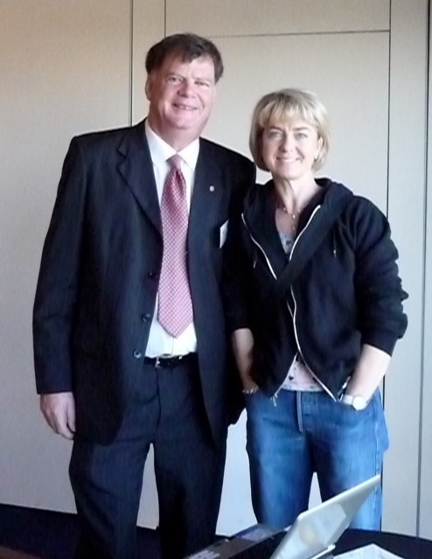
Thank you, Michael Belgrave, Massey University and the school social workers of Aotearoa for organizing this event to explore how social work in schools has contributed to fostering children's rights and how this objective can be further enhanced in the third decade of the UN International Declaration on the Rights of the Child.

Photos by Eva Mari Thomas (with Michael in photo)

How do kids feel about visiting the school social worker?
Young children often love the special attention they receive from a visit with the school social worker, especially if there are games, stories, even jokes. While enjoying the extra attention, they can get help with their feelings and school problems. When pupils reach early adolescence, they may view adult attention with mixed feelings. Yet they need a caring adult to talk to even more as they work through difficult issues of their identity and the teenage world. Ulrika Gustavsson, a school social worker in Norway, has conducted a study to find out how pupils aged 13 through 16 experience their contact with the school social worker.

A Study from Norway, by Ulrika Gustavsson

School social workers have been employed in the schools in Norway in increasing numbers since the 1980’s. However there has been little research into pupils’ experience of working with the school social worker and how it impacts them. The purpose of this study was to find out what was most helpful and meaningful to the pupils in their interaction with the social worker. Interviews were conducted with 8 junior secondary pupils (13 to 16 years old) and 3 school social workers, and the results analyzed to determine how pupils experienced working with the school social worker and what was important to them in the encounter.
Some of the most important findings were that pupils needed to see the social worker as a non-threatening person. The ability to see the school social worker in daily school life, the way the social worker looks at you, even the clothing and the room of the worker are important. Beyond these external aspects, it was important that the social worker listens, asks questions with real interest and helps them to solve their own problems. They felt that the problems were in their own thinking and that the counseling gave them insight into their own lives, helping them to make good choices and to concentrate on their learning. The pupils believed that the social worker helped them with peer relations, with problems such as drinking and smoking and with their feelings, as well as doing better in school and making good educational choices.
The informants did not see the social workers role as an educational role, but as a separate and positive part of school. They found it easy to make contact with the social worker. They found out about the availability of the social worker from other pupils, who told their friends it was a good idea to go to the social worker when they had problems.
All the pupils interviewed felt it had been important to them to talk with the social worker and that it was effective in helping them to solve their own problems. The study shows that school social workers have found a valued place in the schools in the eyes of the pupils.

